**Chapter 1: DATABASE SYSTEM ARCHITECTURE**

**Topic – 1: Introductory Concepts**

**Introductory Terms**

* **Knowledge:** Proper collection of information.

**File Processing System (FPS)**

1. **Advantages:-**
   * Cost friendly, being free or inbuilt.
   * Can be easily learned and used, being basic.
   * High scalability.
2. **Disadvantages:-**
   * Different file formats cause problem accessing.
   * Duplication of data.
   * Difficult to accessing data.
   * Adding new features requires changes in program, and making this change is difficult.
   * Failure during database update leads to inconsistent state.
   * Concurrent access by multiple users.
   * Limited data sharing.

**Purpose Of DBMS**

* + - No need of paper work (compactness).

**Benefits Of DB Approach**

* + - Less rebundancy.
    - Restriction of unauthorized id.
    - Backup and recovery service.
    - Multiple user access.
    - Defined integrity constraints.
    - Data isolation is not an issue.
    - Guaranteed atomicity.
    - More secured.
    - Less program maintenance required.
    - Better backup facility.

**Basic DBMS Terms**

* **Data dictionary:** Information repository containing metadata.
* **Data Warehouse:** Information repository containing data (not metadata).

**Topic – 2: ANSI SPARC Standards**

**Three Levels Of ANSI SPARC Database System**

**Schema:** Anything that describes logical structure of something.

**Internal level (physical schema)**

* This complex data is called **abstraction**.
* Contains internal schema.

**Conceptual level (logical view)**

* It also describes **what** data must be stored, and also sets the relationships among those data.
* But here the internal information like internal structure and abstraction **are hidden**.
* Programmers and data administrators work at this level.

**External Level**

* Contains external schema and other schemas too, collectively called ***subschema***.

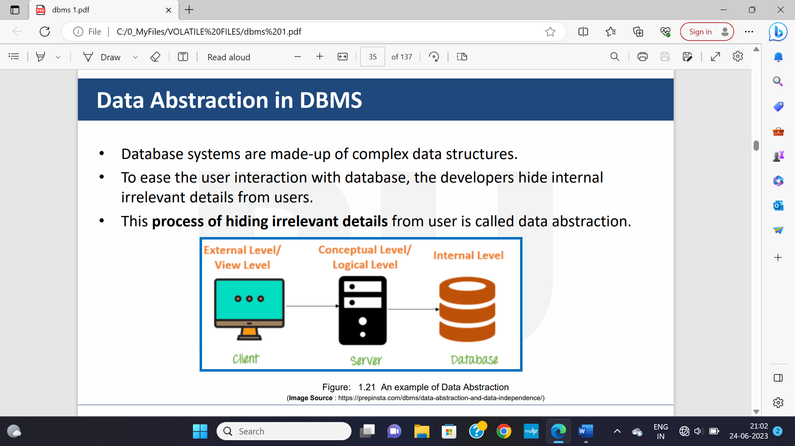

* **Mapping:** **Communication** in between these levels (receiving + transmission).
* **Data independence:** Feature that allows someone to **modify the schema** definition in one level, **without affecting** the higher level.

**Physical Data independence**

* Modifying physical schema without affecting logical (conceptual) schema.
* Changes at **internal levels** are generally done to improve performance of program.

**Modifications At Internal Level**

* File structures
* Compression techniques
* Hashing algorithm
* Storage devices
* **Hashing algorithm:** It is an algorithm used for making data **unreadable** using mathematical functions.

**Topic – 3: DBMS Users**

**Types Of Database Users**

1. **Naïve users:** End users.
2. **Application programmers**
3. **Sophisticated users:** Users who interact with database without using any program, but by tools like SQL.
4. **Specialized users:** User who uses administrative tools.

**Role Of Database Administrator (DBA)**

* Defines logical schema.
* Decides way to represent data.
* Decides how the data will be accessed.
* Takes steps for security of DB.
* Controls authorization over data.
* Provides the required data to the user.
* Assists the application programmer.
* Maintains good performance by making changes at different schemas.
* Responsible for proper backup of the databases.